Transforming Tasks: Workshop 4 Secondary Procedure to problem solving Sorting task 7  What are the five most popular internet memes?  Provide a written report. Include:  • title  • medium (for example photo, animation, etc.)  - number of hits  Secondary Arts  • description (1-2 paragraphs) |  | 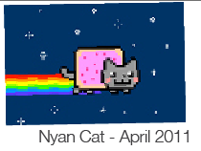  The original Nyan Cat video has received 113,570,384 views on YouTube as of 13 October 2014.  What questions do you have?  Secondary Arts
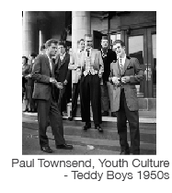  Research one of the key musical styles of the 20th century, such as jazz, rock and roll and punk.  Present your findings in a written assignment that includes the style’s:  • origins i.e. social, historical, political  • characteristics  Secondary Arts  • influences on music that followed  • influences on people and society |  | Music has long been held responsible for leading youth astray and causing the breakdown of society.  It also unites communities in times of celebration and chaos.  What do you need to know so that you can discuss whether these statements are true?  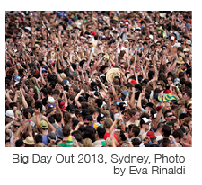Can both statements be true?  Secondary Arts
You and your classmates are at the beach for a swim. You don’t have your bathers on and there are no change rooms. You can’t swim in your clothes. You need a sturdy framework to use as a temporary change room.  Design brief:  Build an enclosure large enough for one adult to stand up with elbow room.  The walls must conceal the person inside.  The structure will have a roof but no floor.  Use newspaper tubes for both the framework and walls.  Materials: newspaper, string  Before you start:  Watch the demonstration of how paper tubes can be assembled into a sturdy framework.  Look at the examples of the paper buildings of Shigeru Ban.  Use a ‘Design, Make, Appraise’  Secondary Arts  process to guide you. |  | You and your classmates are at the beach for a swim. You don’t have your bathers on and there are no change rooms. You can’t swim in your clothes.  In a group of three, build a free-standing structure to use as a change room. It must be large enough for one person to stand up inside with elbow room.  You have only newspaper and string and a specified amount of time to build the structure. Use research and the ‘Design, Make, Appraise’ process to guide you.  Secondary Arts
Max Ernst was one of the pioneers of both the Surrealism and the Dada art movements. He was deeply interested in psychology, the art of the mentally ill, and in creating art from his unconscious and dreams. Ernst had fought in the German army in World War I, and had emerged deeply traumatised and highly critical of western culture. As a result he perceived the modern world as irrational, an idea that became the basis of his surrealist artwork.  One technique was to mock the middle class through the use of collage to create strange and mysterious images of well-dressed people with animal features.  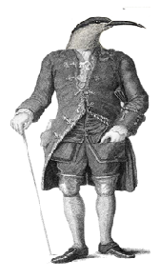Create a surrealist collage in the style of Max Ernst using some nineteenth century illustrations and engravings which you have sourced online.  Secondary Arts  Think of a title for the collage you  have created. |  | Max Ernst was born on April 2, 1891, in Bruhl, Germany., the third of nine children. He was one of the pioneers of both the Surrealism and the Dada art movements. He was deeply interested in psychology, the art of the mentally ill, and in creating art from his unconscious and dreams. His first exhibition was in in Cologne 1912, which was the same year the Titanic sank.  Ernst had fought in the German army in World War I, and had emerged deeply traumatised and highly critical of western culture. As a result he perceived the modern world as irrational, an idea that became the basis of his surrealist artwork. One technique was to mock the middle class by using collage to create strange and mysterious images of well-dressed people with animal features. He escaped to America in 1941 after being questioned by the Gestapo, as the Nazi Party deemed his art degenerate. It is believed two of his paintings were destroyed by the Nazis. Ernst was married four times. He was married to his fourth wife, artist Dorothea Tanning for nearly 30 years. She died in 1976 at the age of 101.  Create a surrealist collage, in the style of Max Ernst, using some nineteenth century illustrations and engravings which you have sourced online.  Secondary Arts  Think of a title for the collage you have created.
T’was brillig and the slithy toves  Did gyre and gimble in the wabe…  All mimsy were the borogoves  And the mome rats outgrabe  Jabberwocky  (Lewis Carroll)  Tell students that this  poem contains many  nonsense words that can  be predicted based on context and picture clues.  Read the poem.  1. Use contextual clues to make lists of the likely verbs, nouns, adjectives, adverbs and pronouns.  2. Find the dictionary meaning of the verbs.  Did you notice?  Carroll left the action verbs intact. This helped the poem to be deciphered. The poem retained the story line, but some meaning has to be inferred.  3. Find out about portmanteau words. Create some portmanteau words of your own.  Secondary English |  | T’was brillig and the slithy toves  Did gyre and gimble in the wabe…  All mimsy were the borogoves  And the mome rats outgrabe  Jabberwocky (Lewis Carroll)  Read the poem.  - What do you think?  - Work with a small group to come up with as many ideas/questions/strategies/predictions as you can, and compare them.  Secondary English
View a visual text, eg non-fiction information video about a topic.  Answer the following questions...  Secondary English |  | View the first few minutes of a visual text.  What questions has it raised? What other questions do you have? What ideas do you have?  If (possible scenario) happens what could result?  Finish watching the visual text.  - Were all your questions answered?  Secondary English  - Have other questions been raised?  - How could you find out more?
Find several newspaper articles and analyse them in terms of bias, using the following questions:  - What is the point of view that the writer is trying to convey?  - What is the evidence that is presented to support this view?  - How well does the evidence support the claims that are being made?  - How credible are the sources of this evidence?  - Is any action done to undermine the credibility of sources that may disagree with the view that is presented? (For example, unflattering photos)  - What might be the motive of the newspaper in presenting this view?  Secondary English |  | Analyse a newspaper article in terms of bias.  Write down the steps you took, and compare to those of another group.  - Can your process be improved?  - Does your process work when analysing other newspaper articles?  Secondary English
Piggy’s glasses were symbolic of wisdom and civilisation in William Golding’s story ‘Lord of the Flies’.  Research online to find out about some of the symbolic features William Golding used in this story.  What was the message he was trying to get across?  Which symbols do you believe were most important?  Secondary English |  | Piggy’s glasses were symbolic of wisdom and civilisation in William Golding’s story ‘Lord of the Flies’. Think about the message you think Golding was trying to get across in this novel, and work in a small group to sort the following features of the story into two piles according to whether or not you believe they also had intended symbolic meaning.  hunts parachute the pig’s head Ralph’s hair colour clothing the Beast body paint the officer the fire the conch the sea the plane the glasses the beach the piglets the littluns Samneric Secondary English the knife  Discuss what each feature might symbolise.  Does everything have symbolic meaning? Explain.
Construct a column graph, to represent your survey data about the time students spend on different out of school activities.  Make sure you:  - Give your graph a title that tells what the graph is about.  - Label both the x and y axes. The x axis tells the scale or frequency, and the y axis identifies the information.  - Include a legend that describes the meaning of the shading or the colours used in the bars.  Secondary Geography | 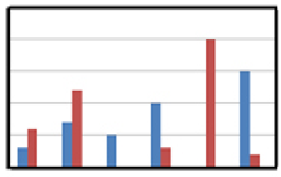  Information ‘under’- load!  - What do you think this graph is about?  - What information might it be representing?  - If the title was about the time children spent on different out of school activities, what would you think?  - What’s missing?  - How might you improve this graph?  Secondary Geography
What does the future hold for Australian biomes?  Australia has extensive tracts of land used for wheat farming. Choose one example of this for a case study. Investigate the changes that this industry has caused to the environment in that place.  Write a report which addresses the following questions:  - Where is the wheat farm?  - Why is it located here?  - What was the original biome for the area?  - How has the area changed?  - How might the original biome be sustainably managed in the future?  Secondary Geography | What does the future hold for Australian biomes?  Australia has extensive tracts of land used for wheat farming. Choose one example of this for a case study. Investigate the changes that this industry has caused to the environment in that place.  Include an answer to - What does the future hold for Australian biomes? Present your research in a report.  The following strategy may help:  - What is the problem about?  - How is it similar or different from other problems I have solved?  - What kinds of information and research strategies would be useful?  - Does my reasoning make sense?  Secondary Geography  - Is it fact or opinion?
Where are Australia’s major mining towns?  Represent the major mining towns on a map of Australia or in a tabulated form.  Show the importance of the mining industry to these towns by ranking them, and then show the ranking visually.  You have access to the following data from ABS website:  - number of people employed in the mining industry  - mine sizes (square kilometres)  - mine productivity GDP contribution/ annum  - Census night populations.  Secondary Geography | Where are Australia’s major mining towns? Represent the major mining towns on a map of Australia or in a tabulated form. Show the importance of the mining industry to these towns by ranking them, and then show the ranking visually.  You have access to the following data from ABS website:  - number of people employed in the mining industry  - mine size (square kilometres)  - mine productivity GDP contribution/annum  - number of women  - size of households  - number of Aboriginal and Torres Strait Islanders  - proportion owner occupied/rental housing  - distance from nearest capital city  Primary Geography  - Census night populations.  Secondary Geography
You are involved in a redevelopment of a sporting venue and your role is to ensure that the people who visit the sports centre have adequate transport options available to them.  Design a survey with a series of questions that would help you to investigate the demographics of the people who will use the redeveloped sporting venue.  Secondary Geography | You are involved in the redevelopment of a sports centre.  Some people suggested building an underground pedestrian tunnel.  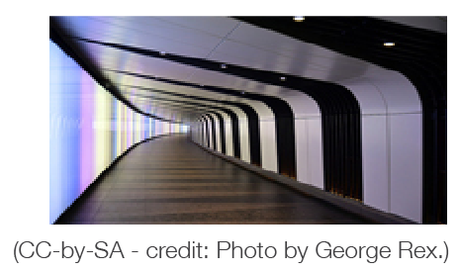What do you think of that idea?  What questions would you ask?  What else might you need to know?  Secondary Geography
Research the discovery of the Mungo Woman in 1969.  Write a report that answers the following:  - Who made the discovery?  - What methods were used to draw conclusions about the longevity of human occupation at Lake Mungo?  - Why is the discovery significant?  Secondary History | In 1969 a charred human jawbone was found in a fossil lake of south-western New South Wales. Some say this is the most important find of human remains ever made in Australia.  What do you want to know?  Secondary History
Immigration during the gold rush  The Victorian gold rush of the 1850s attracted a great number of immigrants from all over the world including Chinese, Europeans and Americans.  Choose one of these groups and research their experiences on the goldfields using the websites provided.  Secondary History | Secondary History  Stage coach mystery  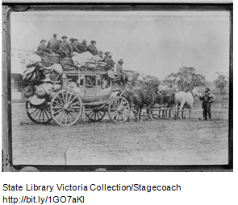Look at the photograph.  Who do you think they are?  Where might they be going?  What information do you need in order to be more certain of your answers?  Work in a small group to devise questions that will help you.  If these are the answers to your questions, what else would you need to know?
Secondary History  The Vikings  Where did the first Viking raiders come from?  Who did they raid?  Describe the ships and weapons that Vikings used in their raids.  - Why were Vikings so successful in these early raids? | Secondary History  How would you survive a Viking raid?  Think about:  - What is the problem about?  - How is it similar or different from other problems you have solved?  - What kinds of strategies/questions will be useful – why?  - 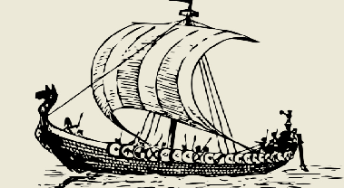Does your solution make sense? Is there a different way?
June 2014 was the 50th anniversary of the Beatles tour of Australia.  Design an exhibition that includes stories, images and artefacts, which explain the impact The Beatles’ tour had on Australia.  Access the following sites to start your thinking:  • Footage of The Beatles arriving in Adelaide  • Film of their arrival in Sydney  • Film of The Beatles performing in Melbourne  • Slideshow of six images from The Beatles tour  • Transcript of The Beatles’ Adelaide press conference.  Secondary History | 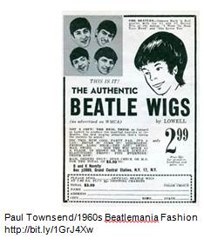  June 2014 was the 50th anniversary of the Beatles tour of Australia.  Design an exhibition that includes stories, images and artefacts that explain the impact The Beatles’ tour had on Australia.  Decide which of the following links will be most useful to start your thinking:  - Footage of The Beatles arriving in Adelaide  - Picture and commentary about Alfred Hitchcock wearing a ‘Beatle wig’.  - A link to a slideshow of popular artists of the 1960’s.  - Film of The Beatles’ arrival in Sydney.  - A link to tours of overseas music artists from 1960 – 1970.  - A link to an English store that sells Beatles memorabilia.  - Film of Beatles performing in Melbourne.  - Slideshow of six images from The Beatles tour.  - Transcript of The Beatles’ Adelaide press conference.  - Blog: The sad decline of music: Cole Porter vs. The Beatles.  Secondary History

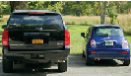My four-wheel drive car is 240 cms wide. My city car is 165 cms wide.  Express the ratio of the width of the four-wheel drive car to the city car.  Secondary Maths | Look at the photograph.  What questions come to mind?  Sort your questions into mathematical and non-mathematical questions.  Which mathematical question would you like to solve?  Secondary Maths
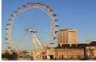In the year 2000, the London Eye, standing at 135m tall, became the world’s tallest Ferris Wheel.  - The radius of the wheel is 60m.  - It travels at an average speed of 0.3m/s.  Calculate:  - The diameter of the wheel  - The circumference of the wheel  - The time taken for one revolution of the wheel.  Secondary Maths | In the year 2000 the London  Eye became the world’s tallest Ferris Wheel.  Approximately how long do you think a journey on the London Eye might take?  Convince me/someone who thinks differently to you.  What do you need to know to be sure of your accuracy?  Secondary Maths
This design is drawn inside a regular hexagon.  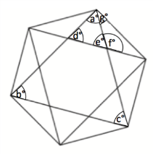  Calculate the marked angles.  Secondary Maths | This design is drawn inside a regular hexagon.  What is the size of the angle marked a?  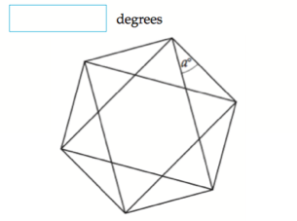  Source: NAPLAN question.  Secondary Maths
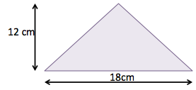  Calculate the area of the triangle  Secondary Maths  . | Calculate the area of the triangle.  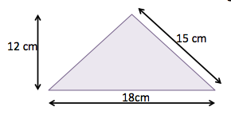  Secondary Maths

Intrusive igneous rocks, such as granite, form from the cooling of magma deep inside the earth. If the rock cools slowly, due to higher temperatures, crystals will have the time to develop.  Extrusive igneous rocks, such as basalt, cool rapidly on the Earth’s surface, usually as a result of a volcanic eruption. Their crystals are small. If the lava fails to form any crystals, obsidian is formed.  When the lava releases a large number of volatile components as free gas, light-weight rocks, like pumice, are formed. As the magma cools, the gas creates bubble-shaped cavities of different sizes.  Secondary Science  Name these igneous rocks. | Look at these igneous rock samples:  - Pumice  - Granite  - Obsidian  - Basalt  What are you wondering?  Secondary Science
Most of an atom is actually empty  Secondary Science  space. For example, a hydrogen  atom is 99.9999999999996% empty space!  The mass of a mole of substance is called its molar mass. The molar mass of an element is found on the periodic table, and it is the element’s atomic weight in grams/mole (g/mol).  1 mole = 6.02214179×1023 (This is Avogardro’s constant).  It is like saying: 1 dozen = 12 eggs.  Using a periodic table, give the molar mass of the following:  1. H 2. Se 3. Ne | ‘If you removed the empty space from the atoms of all people, the whole human race could fit into the volume of a regular sized sugar cube.’  If this statement was true... how could it be possible?  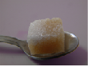Work in a small group to brainstorm any possibilities and to decide what information you need to know.  You may ask your teacher for answers to specific questions, but you will need to explain how the information would be useful for you.  Secondary Science
Complete the following, to show a balanced equation for the combustion of methane.  ? CH₄ + ? O₂  ? CO₂ + ? H₂O  Remember: Combustion reactions produce carbon dioxide and water. Oxygen is required to burn methane.  - Identify each element found in the equation .....C ..... CH₄ ..... O₂ ..... CO₂ ..... H₂ ..... H₂O  - Is the net charge on each side of the equation balanced?  - Do you have to change the coefficients (the numbers in front of the compound or molecule; not the subscripts in the formulas), so that the number of atoms of the element is the same on each side of the equation?  - Check your work to make certain the charge on both sides of the equation is also balanced.  Secondary Science | Secondary Science  You will be writing a balanced equation  for the combustion of methane.  Before you begin, collaboratively devise the steps needed. What strategies might help you to do this task?  What information would be useful or important to know?  Write a balanced equation for the combustion of methane.  Check:  - Is the net charge on each side of the equation balanced?  - Do you have to change the coefficients (the numbers in front of the compound or molecule; not the subscripts in the formulas) so that the number of atoms of the element is the same on each side of the equation?  - Check your work to make certain the charge on both sides of the equation is also balanced.  Remember: Combustion reactions produce carbon dioxide and water.
Draw a pedigree chart for the following scenario:  - A woman’s son has cystic fibrosis, a disease caused by recessive genes.  - Neither of her parents has the disease. What chance is there that her mother is a carrier (heterozygous) for the trait?  - What chance is there that the woman herself is a carrier for the trait?  Secondary Science | Draw a pedigree for cystic fibrosis using information of the Donatella family:  - The father, Vince, and mother, Diane, have three children.  - The two oldest children are Anna and Mary and the youngest child is Teddy. The middle child suffers from middle child syndrome.  - The oldest daughter, Anna, is married to Barry and has an older son, Will, and younger daughter, Vanessa. Mary is married to Sam has a son, Patrick.  - Patrick is the only person in this family group with cystic fibrosis.  - Barry’s brother is a doctor who has treated patients with cystic fibrosis.  - Sam is a truck driver who regularly travels interstate.  - Teddy is not yet married.  - Teddy, Barry and Sam are worried that they may be carriers of the cystic fibrosis gene.  Secondary Science  - Cystic fibrosis is recessive.

